Is it a Thanksgiving, Christmas or Easter Cactus?
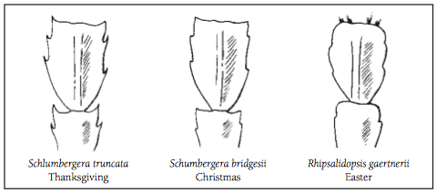
The Holiday season is upon us and that means not only decorations, but holiday plants! This is the time of year when there is an abundance of nice holiday plants to choose from, whether purchased from a florist, nursery or grown at home. One of the most popular plants to give or receive at this time of year is the Christmas cactus. Or is it an Easter or Thanksgiving cactus?
The difference between the three cacti is found in the shape of the leaves. The Thanksgiving cactus (Schlumgera truncata) has very pointed and claw shaped projections on the edges of the leaf. The Christmas cactus (Schlumgera bridgesti) has leaf projections which are more scalloped or tear drop shaped. The Easter cactus (Rhipsalidopsis gaertnerrii) has very rounded edges which are centralized on the leaf.
All of these three cacti are known as short day plants. So, in order to induce the plant into bloom it must have 12-24 hours of darkness and cool temperatures. If you have over summered your plant outdoors or purchased it from a florist or nursery the plant should be kept in a cool location and in a dark area until it sets buds. A seldom used bedroom or lower level is the ideal place. The Christmas and Thanksgiving cactus require approximately 6 weeks of short days in order to bloom whereas the Easter cactus requires 8-12 weeks of short days to bloom hence the name Easter cactus. When the buds appear, it can be brought into a warmer area for your enjoyment. Sometimes a plant might start to drop buds at this time. That could be due to drafts, too-warm temperatures, too much water or direct sunlight. The plants enjoy bright light but not direct sunlight. The plant's soil should be dry to one inch below the surface before watering and not fertilized or repotted while blooming. The plants seem to do the best when root bound.
The Christmas and Thanksgiving cactus may re-bloom again for you in the spring but not as profusely as holiday time bloom. If you want to encourage spring time blooms, simply return the plant to its short-day conditions.
These plants are relatively disease free unless over watered. If the plant turns reddish in color it is an indication of too much sun, lack of phosphorus or lack of water. There are reports of plants being handed down from generation to generation and being over one hundred years old. Enjoy these carefree holiday plants and start a new gardening tradition.

https://www.extension.iastate.edu/linn/news/it-thanksgiving-christmas-or-easter-cactus#:~:text=The%20difference%20between%20the%20three,scalloped%20or%20tear%20drop%20shaped.

