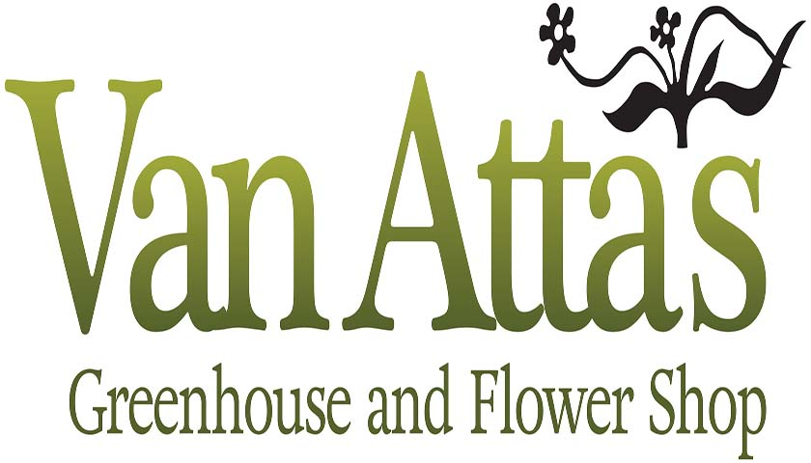

Using Van Atta’s Greenhouse for a Private Business Purpose
We appreciate your desire to use our greenhouse for your event/backdrop. Due to the popularity of groups and businesses using our space, we must implement some guidelines and require prior approval for such use. We recommend you make your request at least one week before your event.
Please submit your request to Plants@Vanattas.com. Include your name, a brief description of the event and the number of people involved. You will receive a response from us within 48 hours.
Please note that indoor space is limited, and the use of this indoor space is NOT available on weekends during the month of May.
Van Atta’s customers are our top priority, so the following guidelines must be observed to keep our property available for private business purposes.
• Customers and staff always have the right-of-way. You must be aware of anyone potentially needing access to your location. The presence of your group must in no way restrict access to products and facilities for our customers and staff.
• The individual requesting permission is responsible for their group’s actions and conduct while here.
• Events must be limited to 2 hours or less per day and must conclude at least one hour prior to the posted store closing time.
• Running is not allowed.
• Climbing on or moving benches, tables, structures, or displays is not allowed.
• Children/infants are not permitted to be placed on benches, tables structures, or displays, whether seated, standing, or laying down,
• Plant material in the greenhouse must remain on the tables. Benches. It is not to be placed on the floor.
• Picking of flowers and trampling or mashing of plants in the greenhouse and gardens is prohibited.
• Personal belongings such as coats, jackets, bags, and equipment must not be placed on any retail benches, tables or displays where items are being sold, in restrooms or in walkways.
• We have a limited number of restrooms; they are not to be used as dressing rooms. • We are not responsible for lost or stolen items.

